Project Design Phase-II
Technology Stack (Architecture & Stack)
Date | 08 October 2026
Team ID | [TEAM ID]
Project Name | Auto Ticket Classification Using ServiceNow Flow Designer
Maximum Marks | 4 Marks

Technical Architecture:
The Deliverable shall include the architectural diagram as below and the information as per the table1 & table 2
Example: Automatic ticket classification on a ServiceNow instance
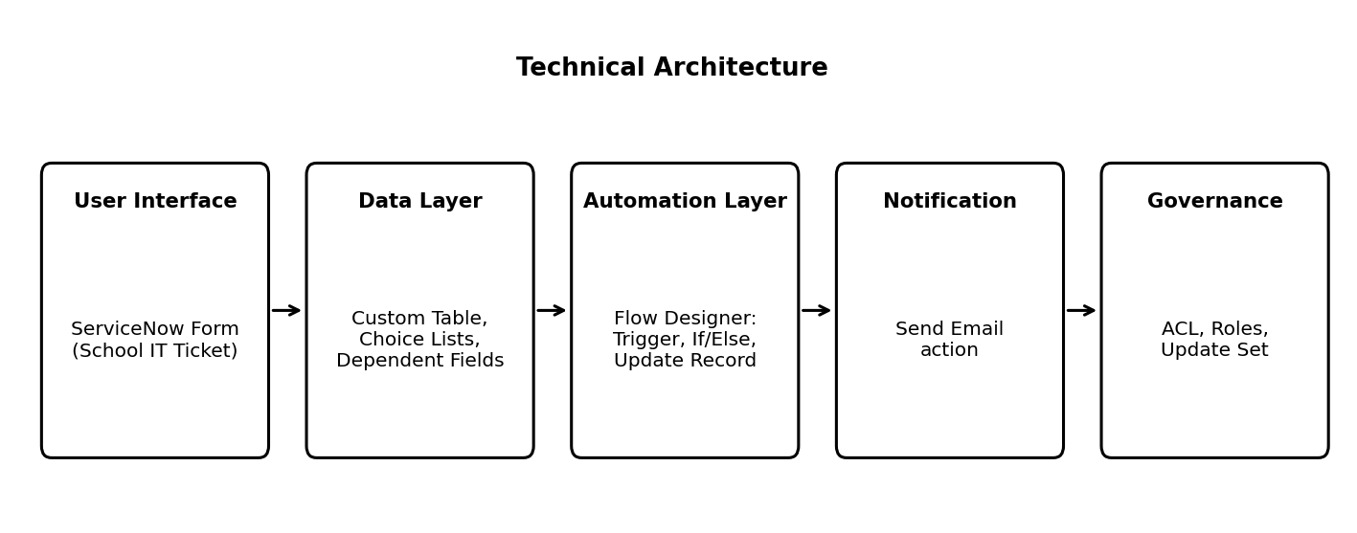
Table-1 : Components & Technologies:
S.No | Component | Description | Technology
1 | User Interface | Form through which the Caller enters Caller and Short Description | ServiceNow Form (School IT Ticket) designed with Form Designer
2 | Application Logic-1 | Detects creation of a new ticket | Flow Designer trigger: Created (School IT Ticket table)
3 | Application Logic-2 | Evaluates keywords in Short Description and Description and decides the category | Flow Designer If / Else conditions with data pills
4 | Application Logic-3 | Updates Category and Subcategory of the ticket | Flow Designer action: Update Record
5 | Application Logic-4 | Notifies the Caller about ticket creation | Flow Designer action: Send Email
6 | Database | Stores ticket records, fields and choice values | ServiceNow custom table: School IT Ticket
7 | Choice Dependency | Restricts Subcategory options based on Category | Dependent field (Dictionary) configuration with choice lists
8 | Configuration Management | Captures all configuration changes | ServiceNow Update Set (Project Update Set, Global)
9 | Platform | Hosts all components | ServiceNow instance

Table-2: Application Characteristics:
S.No | Characteristics | Description | Technology
1 | Open-Source Frameworks | No open-source framework is used. The solution is built with the no-code tools provided by ServiceNow. | ServiceNow platform tools
2 | Security Implementations | Access to the School IT Ticket table is restricted to authorized users through access control rules. | ServiceNow Access Control (ACL) and roles
3 | Scalable Architecture | New keywords, categories and subcategories can be added by extending the flow conditions and choice lists. | Flow Designer, choice lists
4 | Availability | The solution runs inside the ServiceNow instance and depends on its availability. | ServiceNow instance
5 | Performance | The flow runs automatically when a ticket is created and updates the record without manual steps. | Flow Designer record trigger

References:
https://docs.servicenow.com
https://developer.servicenow.com

